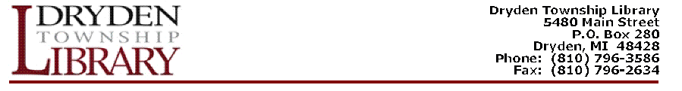
Library Clerk

The Dryden Township Library is seeking a part-time Library Clerk for the
circulation desk. Requires high school diploma, excellent customer service
skills, use of Internet and Windows based programs, high degree of organization,
and dependable. Library experience is preferred, but willing to train. Schedule
includes one evening and Saturday hours, 18-25 hours a week. Please send
resume to Dryden Township Library, 5480 Main Street, Po Box 280, Dryden, MI 48428, Email Resume: drydentownshiplibrary@gmail.com, or fax to 810-796-2634.

